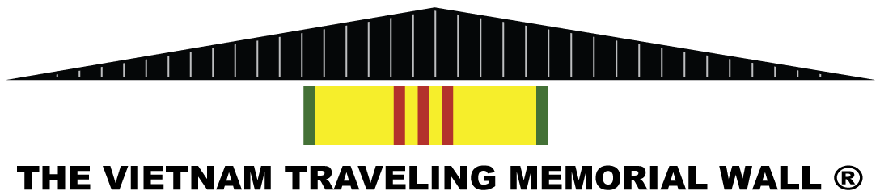
Coming to Long Valley, New Jersey
Opening Ceremony September 29, 2023, at 10:00 AM
September 28, 2023, through October 1, 2023
Guest Speakers:
Colonel Charles S. (Chick) Ciccolella, Army retired, Vietnam Vet, 101st Airborne, Fmr Asst Secretary of Labor, VETS
Mr. Matt Murello, Mayor Washington Township
Palmer Park – Bartley Rd & Palmer Place
Make Checks Payable to “Washington Township” with “Vietnam Traveling Memorial” in the memo lineMail checks to: 43 Schooleys Mountain Rd, Long Valley, NJ 07853

Contact: Brian McGuire 973-216-0078 bfmac123@gmail.com
Name: ______________________________________________________

Address: ____________________________________________________

City, State, Zip: ______________________________________________

Phone: ___________________________Email: _____________________

Donation: $___________________

Presented by The American Legion Post 342 & American Veterans Association Post 1776

