Washington Township Green Team Meeting Agenda
Tuesday September 4th 2018 6:30pm
(Abbreviated work session)
Washington Township Municipal Building
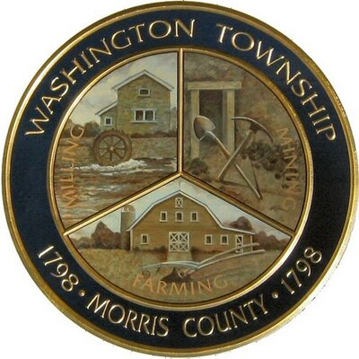

Members Present: __x_Chairman Dan Ross _x__Member Paula Ross, ___Member Patricia Homer __Committee Liaison Ken Short_x_Township Committeeman Gregg Forsbrey ____ Member Valerie Walsh
Others Present: ___Town Administrator Andrew Coppola __x_David Belsky __x_Denise Spina-Belsky
6:30pm Meeting Call to Order
6:35-6:45pm Old Business;
Harrington Fields Pollinator Meadow
- Progress so far, work needed?
- Upcoming workdays, and fall seeding
- Possible trail maintenance.
6:45-7:00pm New Business:
Market at Long Valley
- Reporting back on progress so far
- Reflecting on challenges
- New vendors, and promotions
- Looking ahead to next year, Market Committee?
7:00-7:15pm
Green Festival
- Updated list of our current vendors/ exhibitors
- Who is available to attend/ table and when?
- Updates on prizes and table display?
- Last minute logistics

7:15-7:30pm-
Miscellaneous:
- Upcoming initiatives, clean communities dates/ sign up
- Outreach and communications updates?
- Fundraising and new membership?
Call to adjourn: 7:28pm

