Washington Township Green Team Meeting Agenda
Monday March 5th 2018 6:30pm
Washington Township Municipal Building
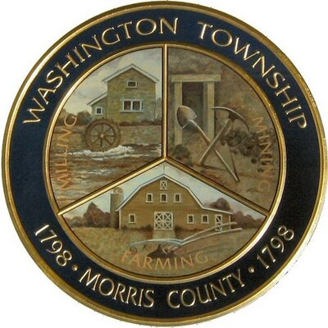

Members Present: __x_Chairman Dan Ross _x__Member Paula Ross, ___Member Patricia Homer ___Committee Liaison Ken Short___Gregg Forsbrey
Others Present: __x__ EC Member Valerie Walsh ___Town Administrator Andrew Coppola

6:30pm Meeting Call to Order

6:35-6:45pm Approval of February 2018 Minutes.

6:45-7:10pm Next steps at Harrington Park, remaining deliverables, and upcoming spring workday. Ideas for next undertaking.

7:10-7:35pm Sustainable Jersey updates: Green Cleaning Products, Recycled content paper products, Reviving the green market, possibly at Ort Farms? Partnering with schools. Patty’s updates on Board of Education, discussion with A.J. from school board, TREX Challenge, new priorities.

7:35-8:00pm- Clean Communities Week, Green Festival Updates.

8:00-8:15pm- Fundraising- WTGT totes?

8:15-8:30pm- Open discussion, Membership, Outreach

