Washington Township Green Team Meeting Agenda
Monday November 5th 2018 6:30pm
Washington Township Municipal Building
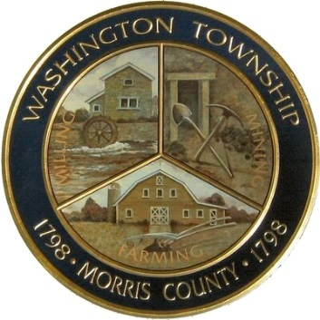

Members Present: __x_Chairman Dan Ross _x__ Paula Ross __x__ Valerie Walsh
_x__David Belsky _x__Denise Belsky
Members of the public: John Daley and Gertrude Daley
6:30pm Meeting Call to Order
6:35-6:45pm Old Business;
Harrington Fields Pollinator Meadow
- Putting the meadow to bed, next steps.
- Looking ahead to next year.
6:45-7:00pm
Paper Shredding/ Clean Communities Feedback
- Final amounts and totals
- Looking ahead to the spring CC day.
7:00-7:15pm
Market at Long Valley
- Wrapping up after the season
- Searching for a new Market Manager
- Setting tentative dates for 2019
- Market Sponsors, and new vendors?
7:15-7:30pm- New Business
Sustainable Jersey
- SJ actions in which we are currently engaging
- Solar Friendly Ordinance updates
- Reporting back and updating our points by June
7:30-7:45
Treasurers Report/ Voting on October's Minutes
7:45-8:00pm-Miscellaneous:
- Upcoming initiatives/ new project ideas
- Outreach and communications updates?
- Fundraising, voting on spending items.
Call to adjourn: 7:38pm

