Washington Township Green Team Meeting Agenda
Monday July 2nd 2018 6:30pm
Washington Township Municipal Building
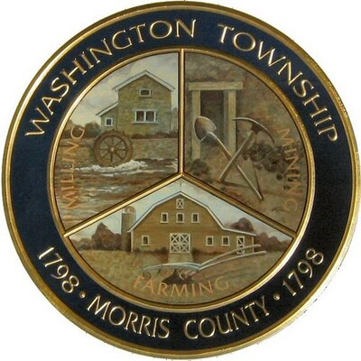

Members Present: __x_Chairman Dan Ross _x__Member Paula Ross, __x_Member Patricia Homer __Committee Liaison Ken Short__Township Committeeman Gregg Forsbrey ____ Member Valerie Walsh
Others Present: ___Town Administrator Andrew Coppola __x_David Belsky __x_Denise Spina-Belsky
6:30pm Meeting Call to Order
6:35-7:10pm Old Business;
Harrington Fields Pollinator Meadow
- Final Report and Addendum sent to ANJEC
- Recognition in the Observer Tribune.
- Discussing a watering schedule?
- Looking ahead to bench installation, maintenance and trail work.
TREX Challenge
- Challenge completed, updates on benches?
- Any ideas or suggestions for something similar?
7:10-7:45pm New Business:
Green Market
- Updates on progress, new starting date, new vendors, visiting Chester Market
- Addressing new obstacles or barriers to progress, mitigating concerns.
- Parking signage updates, last minute concerns.
- Market tasks, objectives and roles.

Green Festival
- Updates, thoughts on new vendors or non-profits?
- Sponsors, approaching the Long Valley-Chester Rotary Club?
- Passport game, potential of market vendor making custom stamps?
- Proposed theme of reducing plastic, any new prizes suggestions?

7:45-8:00pm- Upcoming initiatives:
- Installing benches and working with the Ad Hoc Trails Committee on implementing the interpretative path, aiming for late summer butterfly release?
- Meeting with AJ to discuss possible partnership with the LVMS on front rain garden?
- Fall Clean Communities Week/ Paper Shredding event.
- New opportunities to collaborate? Pooling volunteers?
8:00-8:15pm- Miscellaneous:
- Fundraising- New ideas? Any new grants available?
8:15-8:30pm- Open discussion:
- Increasing membership, Bolstering Outreach, Updates on Social Media Page? (500 likes this week!) Need to create a page for the Market as well.

