Washington Township Green Team Meeting Agenda
Monday February 5th 2017 6:30pm
Washington Township Municipal Building
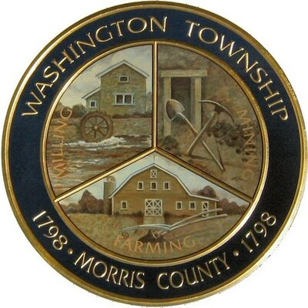

Members Present: __x_Chairman Dan Ross _x__Member Paula Ross, ___Member Patricia Homer ___Committee Liaison Ken Short___Gregg Forsbrey
Others Present: __x__ EC Member Valerie Walsh ___Town Administrator Andrew Coppola

6:30pm Meeting Call to Order

6:35-6:45pm Approval of December 4th 2017 Minutes. Official appointments, and Updates

6:45-7:10pm Progress at Harrington Park, and next steps looking towards the spring, and remaining deliverables. Thoughts on the brochure. Suggestions moving forward and looking ahead.

7:10-7:35pm Sustainable Jersey updates: Green Cleaning Products, “Fix it Day,” reviving the green market? Partnering with schools.

7:35-8:00pm- New members, Outreach

8:00-8:15pm- Fundraising (Clean Communities Week/ Plant Sale)

8:15-8:30pm- Open discussion

